Phase I
Anatomic Shoulder Replacement Exercises
---------------------------------------------------------------------------------------
Nami Kazemi, MD
Washington Orthopaedic Center

Phase I exercises after an anatomic shoulder replacement focus on PASSIVE range of motion exercises. These exercises are designed to increase motion. In these exercises, the operated arm is moved either by the physical therapist or with the assist of the opposite arm or gravity.

Perform these exercises three times a day.

Pendulum Exercises

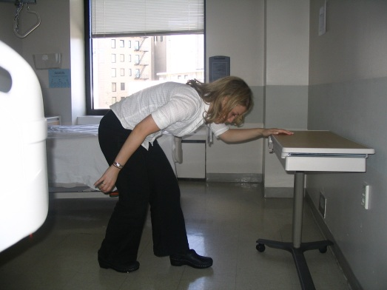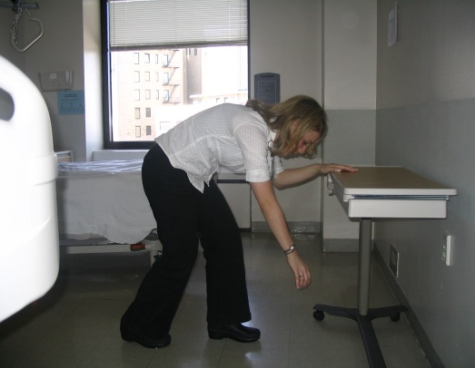

Bend over at the waist and support yourself with your good arm. Let your operated arm and hand relax with gravity. Then move your torso and let your operative arm passively swing. It is important NOT to fire the shoulder muscles for this exercise and just rely on the torso movement. Perform the following movements 10x each.

- Shift your body weight forward and backward
- Circle clockwise
- Circle counter-clockwise

External Rotation with Stick

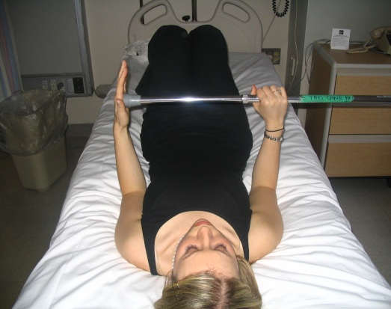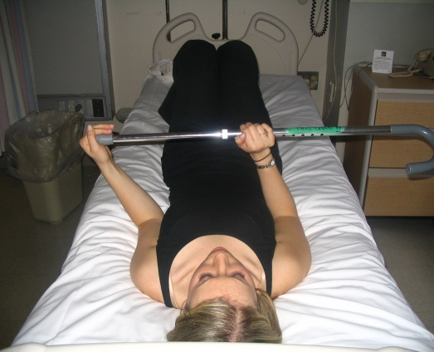

Lie on your back. Bend your elbows to a right angle (90°) and hold close to side of body. Hold stick with both bands. Using your good arm, gently push the operated arm out to the side. Repeat 10x.

* PRECAUTIONS:

- DO NOT move your arm beyond ___30___ degrees

Assisted Shoulder Elevation

These exercises should be performed in the plane of the scapula as demonstrated below:

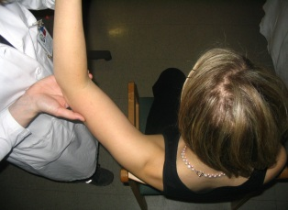
(overhead view)

  - With another person:

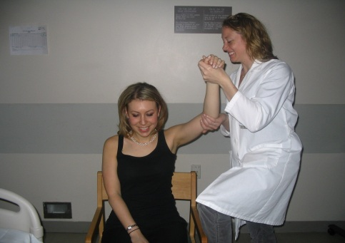

The assistant supports your arm at the hand and the elbow. Relax your arm as the assistant passively elevates your arm out slightly then up. Assistant should slowly lower arm down to starting position.

* PRECAUTIONS:

- Do NOT elevate arm beyond ___130___ degrees

Additional Exercises

a) Bend and straighten your elbow:

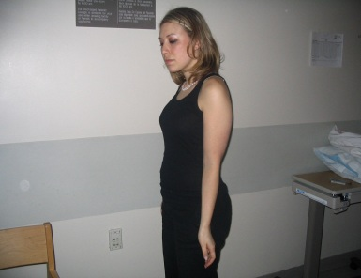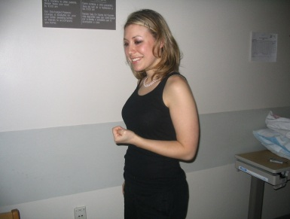

- With your elbow bent at a 90° angle, turn your palm up and down:

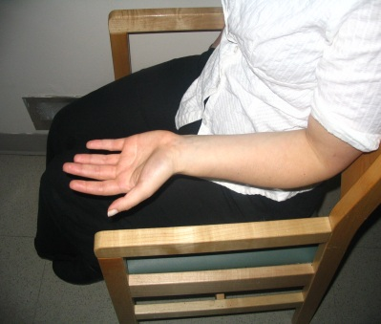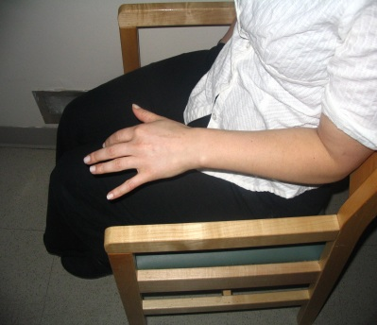

- Bend your wrist back and forth:

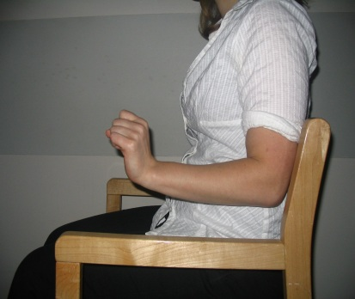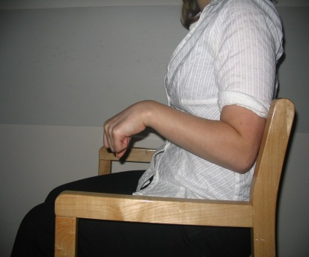

- Open and close your fingers:

