Phase I
Reverse Shoulder Replacement Exercises
---------------------------------------------------------------------------------------
Nami Kazemi, MD
Washington Orthopaedic Center

Phase I exercises after a reverse shoulder replacement mainly focus on elbow, wrist and hand exercises in addition to pendulum exercises. These exercises are designed to decrease swelling in the operative extremity and promote some motion.

Perform these exercises three times a day.

Pendulum Exercises

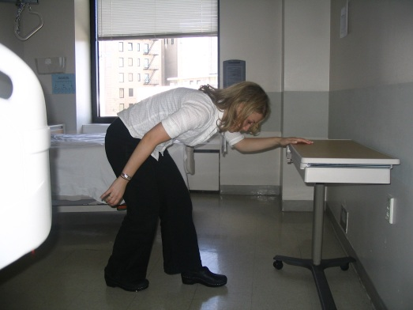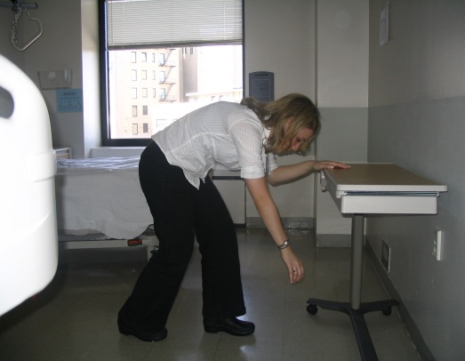

Bend over at the waist and support yourself with your good arm. Let your operated arm and hand relax with gravity. Then move your torso and let your operative arm passively swing. It is important NOT to fire the shoulder muscles for this exercise and just rely on the torso movement. Perform the following movements 10x each.

- Shift your body weight forward and backward
- Circle clockwise
- Circle counter-clockwise

Additional Exercises

a) Bend and straighten your elbow:

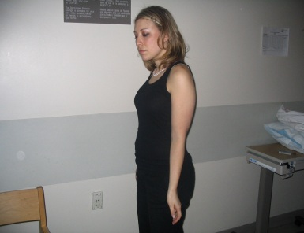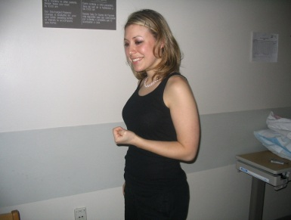

- With your elbow bent at a 90° angle, turn your palm up and down:

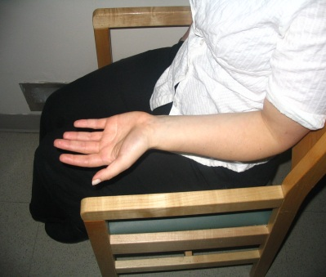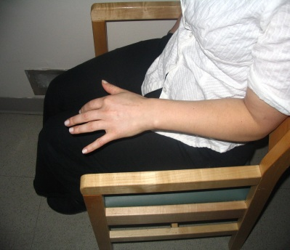

- Bend your wrist back and forth:

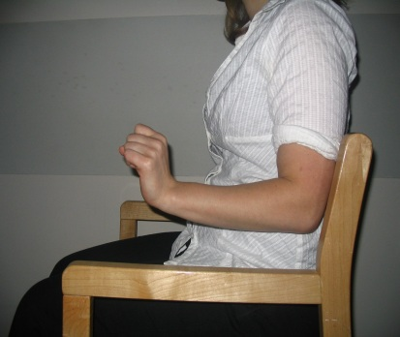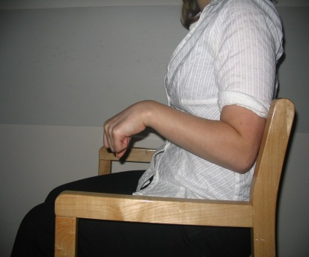

- Open and close your fingers:

